Linux Programming: Assignment – 8

1) What is a user-defined function in shell scripting? Explain with an example.
- A user-defined function in shell scripting is a custom block of reusable code created by the user to perform a specific operation.
- It helps avoid code repetition — once defined, you can call the function multiple times anywhere in your script.
Example:
#!/bin/bash
greet() {
echo "Hello, welcome to Linux scripting!"
}

# Calling the function
greet

2) Write a bash script with a function that multiplies two integer numbers.
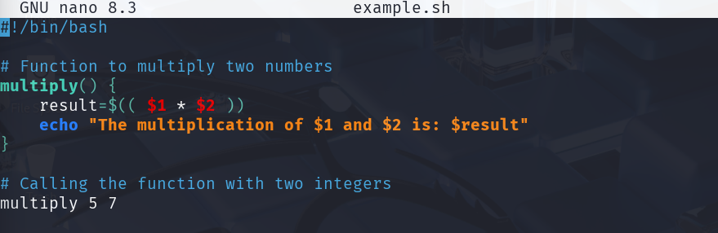
3) Explain how arrays (1D, 2D, and 3D) are declared in bash scripting.
1D Array
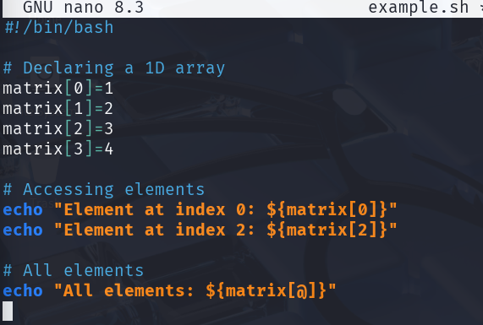2D 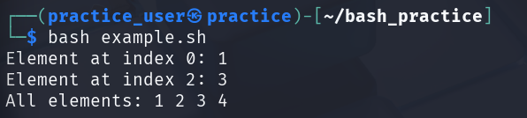

4) Write a shell script to display elements of an array.
#!/bin/bash

# Declare an array
fruits=("Apple" "Banana" "Cherry" "Mango")

# Display array elements
echo "List of fruits:"
for fruit in "${fruits[@]}"
do
echo "$fruit"
done

5) What is the purpose of cron in Linux?
- Cron in Linux is a time-based scheduler that executes commands or scripts automatically at fixed intervals or specific times.
- It runs as a background daemon and reads tasks from a crontab file.
- It’s mostly used for repetitive jobs like backups, cleanup, and monitoring.
- Cron runs even when the user isn’t logged in, ensuring tasks continue automatically.

6) Write a cron job to run a backup script every day at midnight.
Let’s assume we created a script named midnight_reminder.sh that displays a message at midnight.
#!/bin/bash
message="Goodnight, Vishal! Time to rest."
echo "$message"
echo "$(date): $message" >> /home/user/midnight_reminder.log
To schedule it:
- Make the script executable:
- chmod +x /home/user/midnight_reminder.sh
- Open crontab:
- crontab -e
- Add this line:
- 0 0 * * * /home/user/midnight_reminder.sh
This ensures the script runs every day at 00:00 (midnight), updating the log file automatically.

7) How do you schedule a one-time job using the at command?
- The at command schedules a command or script to run once at a specific time.
- Unlike cron, it doesn’t repeat.
Example:
To run the same reminder script once at 10:30 PM:
at 22:30
/home/user/midnight_reminder.sh
(Then press Ctrl+D to save and exit.)

8) Write a script to display disk usage using df and du.
#!/bin/bash
echo "Disk usage overview:"
df -h

echo "Detailed usage in /home:"
du -h --max-depth=1 /home
- df -h → shows disk usage of all mounted file systems in human-readable format.
- du -h --max-depth=1 → shows space used by each directory within /home.

9) How can you log the output of a script using the tee command?
You can record the output of a script while also displaying it on screen using tee.
Example:
./script.sh | tee output.log
This will print the output to the terminal and save a copy to output.log.

10) Explain with an example how shell scripting can automate system administration tasks.
- System administrators often need to track disk space, system logs, or backups.
- Instead of manually checking these, a shell script can perform the tasks automatically.
For instance, the script from question 8 can be added to cron:
crontab -e
0 0 * * * /home/user/disk_usage.sh
This will execute the script daily at midnight, save the results to a log file, and free the admin from checking manually.
Thus, shell scripting enables automatic monitoring and maintenance of system resources.

